History 7 Name:
The Mayans: An Urban Planning Simulation Date:

- Background: The Mayans of southern Mexico and northern Central America reached its height between the 3rd and 10th centuries. Its cities were focal points of religious celebrations involving pyramid-style temples and the worship of numerous gods. Government was conducted and priests and rulers lived in these communities as well.

To that end, the hob of a Mayan city was its temple with priests residing close by. Since nobility ruled, ruling families also lived close to the city’s center. As the empire declined over time, people lived farther away from the center of the city. Wealthy artisans and merchants resided farther out than the ruling classes, yet they were much close than the multitude of peasants. They were farthest removed as they took care of the fields on the perimeter of the city.

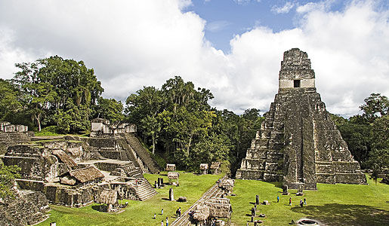
The photo depicts the Mayan city of Tikal in present day Guatemala.

Overview of the simulation: Today you will be participating in a simulation. You will each be given one of the following roles: priest, noble, artisan, merchant or peasant and you will be seated according to the status and privileges that you have in your society; your seat and role card will determine how much influence you have in designing the lay-out of your city. Your goal, as an entire class, is to work together and plan how you will develop a new territory into a thriving city.

Directions:

Step One: Based on your seating arrangements, you will likely find it difficult to communicate clearly with all members of your society. Nobles and merchants should initiate conversations with the peasants, who are faced in an opposite direction. As you conduct your conversations with your peasants, you will face some challenges. They will not be able to respond unless you mention a specific phrase or word. My advice, appeal to their customs and make them feel welcome and perhaps you’ll have their cooperation. Once you can get a peasant to “turn around” they will be able to help you work and implement your design for the new city.

Step Two: While nobles and merchants are working to gain the trust, respect and cooperation of peasants, the priests and artisans will be working on creating a lay-out for your new city. I encourage priests and artisans to return to the reading on p. 404- 409 to collect details about their art, agricultural life, cultural achievements, religious beliefs, symbols, artifacts, etc. See provided worksheet to brainstorm and design the lay-out of your new city.

Step Three: After the nobles and merchants gain the respect of their workers, the peasants, I encourage them to take inventory on their supplies. You will need the following:

- At least 200 blocks of limestone (limestone are the black legos)
- At least 100 blocks of flint (flint are the grey legos)

Step Four: After the inventory has been taken, you should consult your city planners, or the priests and artisan. Wait for instructions about how you can help contribute to the planning your city. Please keep in mind peasants, nobles and merchants are responsible for implementing the priest’s and artisan’s designs. Priests are overseers and they should check to ensure that they plan is being carried out effectively.

Step Two: Designing a new city! Your new, thriving city must include the following features:
- Two holy temples (in classic pyramid-style), use provided Legos to build these structures. 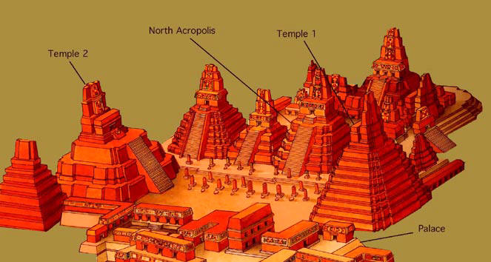
- Stone figures (draw or see ‘cut-outs’)
- Open court areas
- “Steles” or pillars (draw or see ‘cut-outs’)
- Farming areas (draw a field/terrace, see page 406)
- Hieroglyphic designs (draw or see ‘cut-outs’)
- A Mayan calendar sculpture (draw or see ‘cut-outs’)

History 7 Name:
City Planner Worksheet Date:

As city-planners, you will develop the plan about your city will appear. It’s your job to delegate or assign specific jobs too. Keep in mind that peasants, nobles and merchants should be ready and willing to help you create your thriving new metropolis! Delegate group responsibilities.

Here’s an example of how some Mayan cities were planned and organized.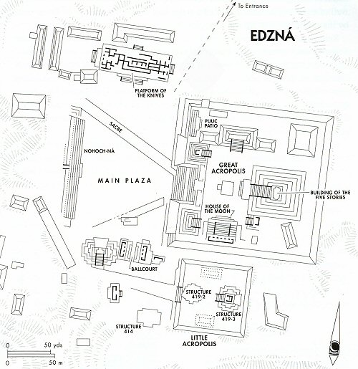
Your city must include the following different aspects:
- Two large pyramid-style temples that honor their gods and the importance of nature; this is the focal point of your civilization. You should build your city around these sacred religious areas.
- Stone figures (draw or see ‘cut-outs’)
- Open court areas
- “Steles” or pillars (draw or see ‘cut-outs’)
- Farming areas (draw a field/terrace, see page 406)
- Hieroglyphic designs (draw or see ‘cut-outs’)
- A Mayan calendar sculpture (draw or see ‘cut-outs’)

The Geography of Your City: “The Mayans settled in a fertile area that stretched close to surrounding bodies of water including the Pacific, Gulf of Mexico or Caribbean sea. (See provided map.)

Step One: Determine where your city will be built. Consult your team of city-planners and review the costs and benefits of your geographic location and mark the location on the map below. The triangles represent other cities

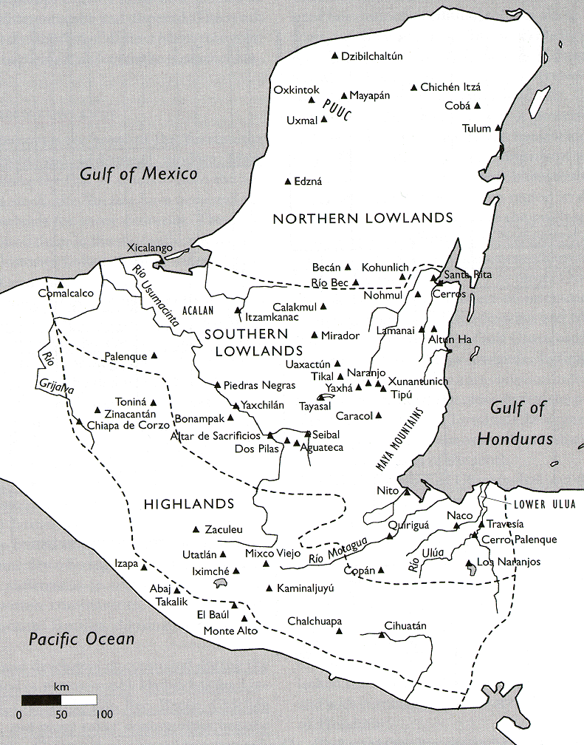

Cut-Outs: Helpful sources for your planning: (You may cut-out the images and tape them as needed to your Lego city) You may want to delegate these jobs to other group members.
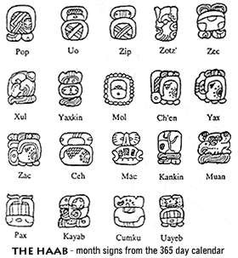Above: Examples of Hieroglyphs
Below: Examples of Mayan sculpture
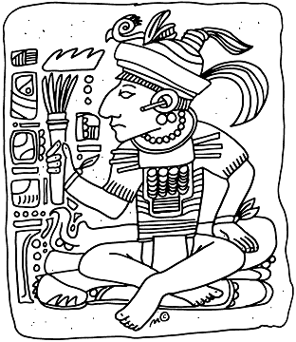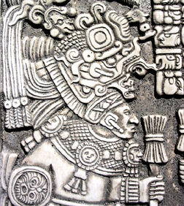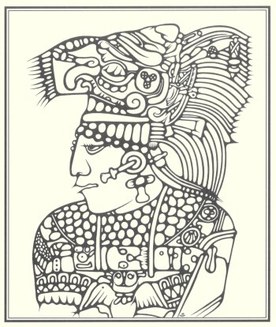

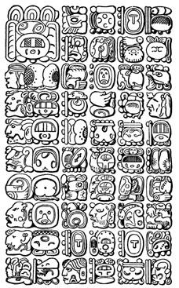A Mayan “steles” or columns

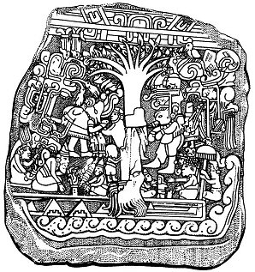

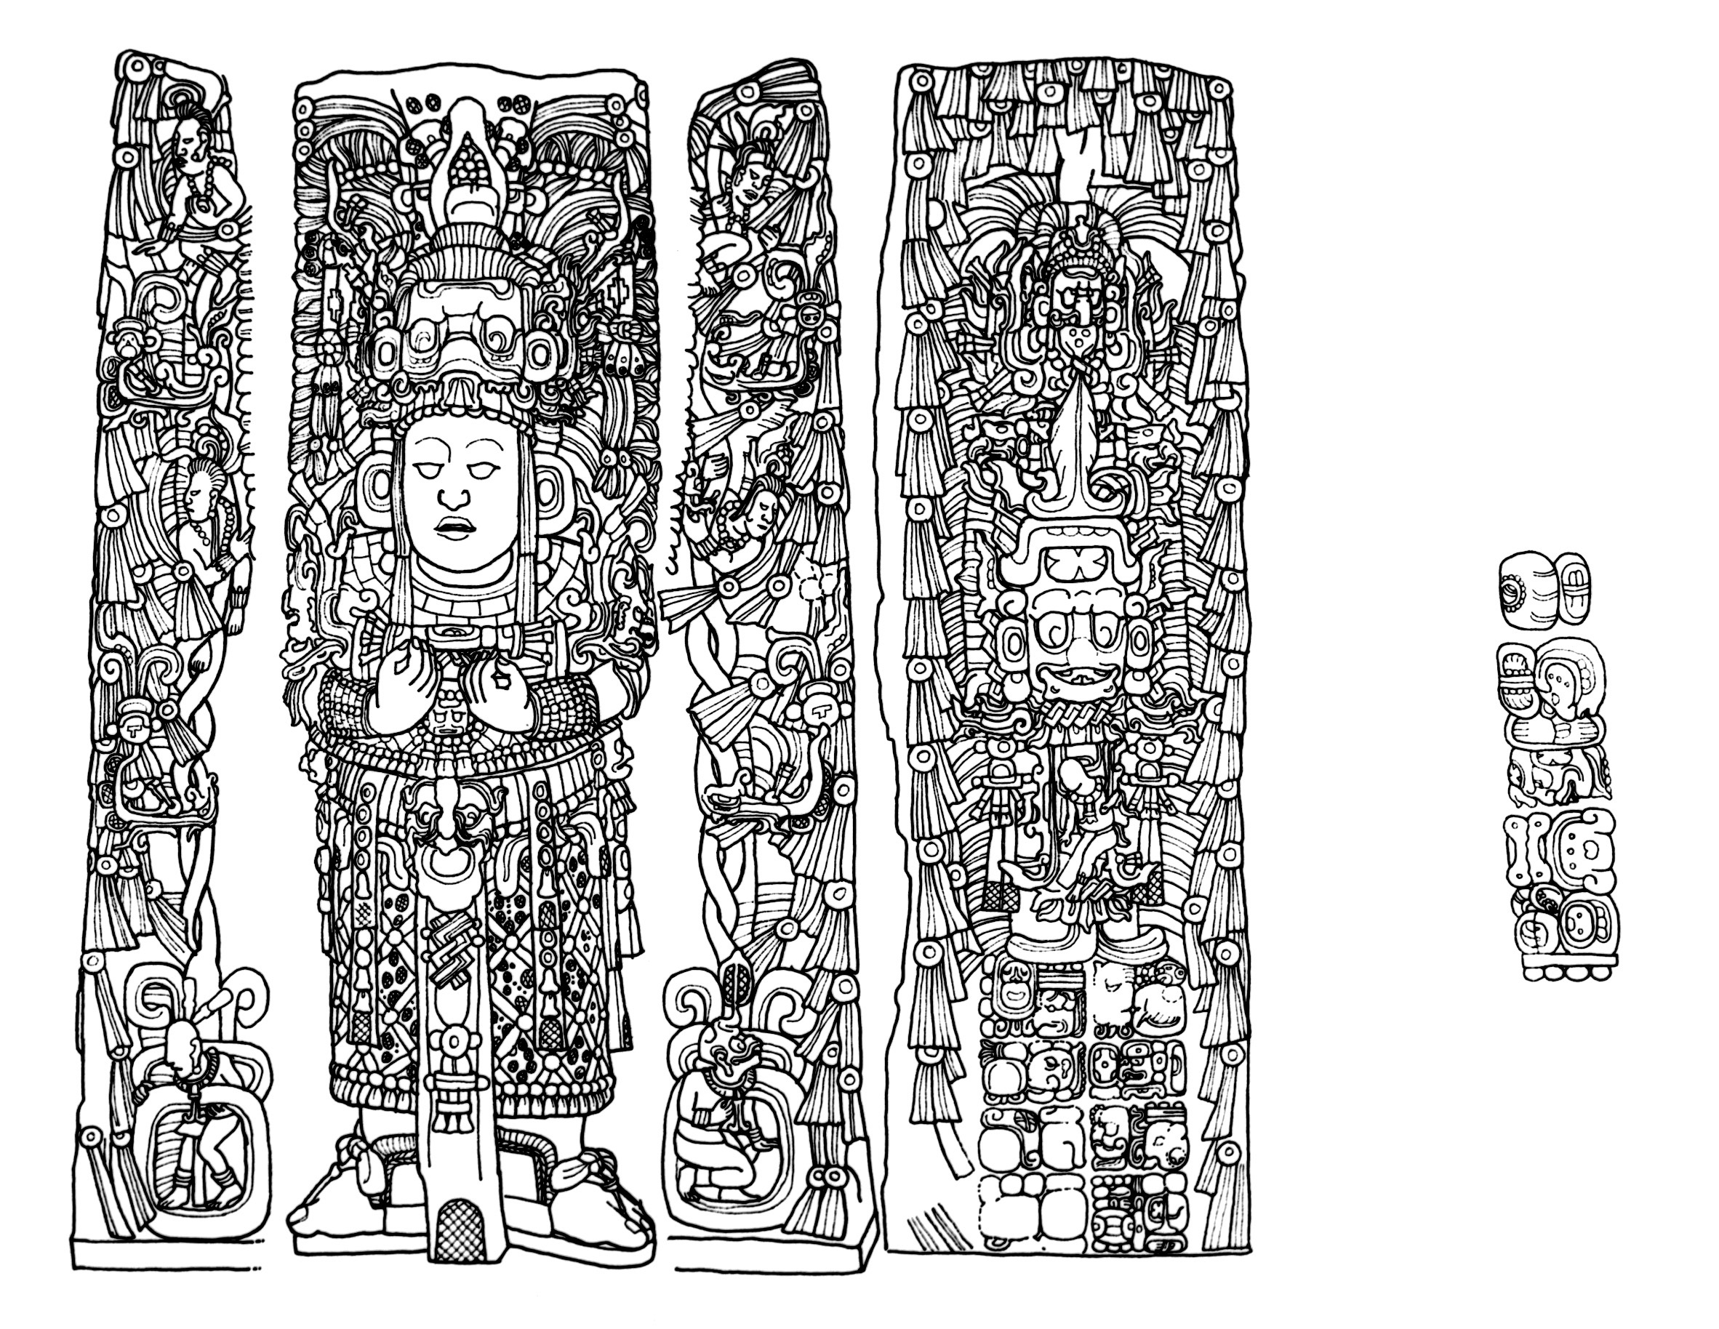
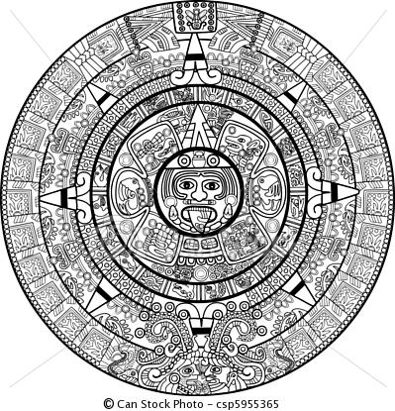
Mayan Calendar

