As a teacher of non-Western history, I am interested in deepening my understanding about the 3,000 year old history behind present-day Istanbul. Like the National Council for Social Studies Teachers, I share a common passion to “examine the nature of cultural differences and act to influence an international understanding of tolerance and empathy.” Teaching history for many years has afforded me a unique opportunity to explore past cultures, relate them to the present and bring history to life through the use of innovative teaching methods like simulations, narrative writing and primary source analysis. This academic venture in Istanbul would give me an opportunity to seek out new sources, collaborate with experts and fellow teachers and develop new methods that will encourage my students to be more thoughtful and compassionate citizens of the world. With a focus on academia rather than tourism, the Summer Institute in Istanbul will provide teachers, like myself, with a rare look at how various cultures connected, shared and merged to develop a unique identity that shifted as various groups overtook the territory. Armed with this new knowledge, I am prepared to join forces with other attendees to develop new strategies that engage learners, promote tolerance, gender equality and empathy of cultures in the past and today.
My 7th grade non-Western class is centered on the idea of cultural diffusion, and much of our study focuses on what happens when cultures collide or connect. Embedded in the curriculum is a more subtle focus on character education, and mirrored in the curriculum are examples of how virtues were important in the past and how they continue to be important in their personal and academic life. By studying the Ottomans, for example, we have learned about how religious tolerance was a means to unite people in a diverse empire.
Teaching middle school requires a certain degree of innovation and “thinking outside of the box.” To successfully engage my students, I rely on a variety of simulations and “hands on” history labs to enhance their learning experience. Through the use of simulations, students become at “the center” of their learning experience, and their connections to a real or imagined character of the past allow them to use historical empathy to better understand the conditions, struggles and challenges of the time period, as if they are a part of the history. With a focus on an experience rather than content, my students are able to utilize their rich and vivid historical imagination.

For example, in my 7th grade non-Western medieval history class, I frame our entry into our Ottoman unit with a crime scene investigation. The students are broken into small groups, and each group is presented with cordoned off area of the room with one challenge, to determine what caused the collapse of the Byzantine Empire. This “History CSI” (see image below) investigation begins with a close look at the provided clues, which are comprised of primary and secondary sources. Some sources are playfully reimagined by myself, and include: a disgruntled farmer’s letter to his emperor, journal entries from a Byzantine and Ottoman soldier, a Venetian coupon that offers discount on trade routes (fine print: the offer expires in March 1453) and two paintings that capture different perspectives of the siege of Constantinople; a heroic Delacroix painting and another from the perspective of tired and starving Byzantines. As a first step, they investigate the clues for probable causes with their group of fellow investigators. Their next step is to recreate the “crime scene” by illustrating a picture of what happened to cause the collapse of the empire. Our class ends with a debriefing where each group shares their investigation and their crime scene posters, and as they prepare to leave class I have them listen to “Istanbul (not Constantinople)” by The Four Lads as another way to remind them of the transformative change in the culture’s identity.
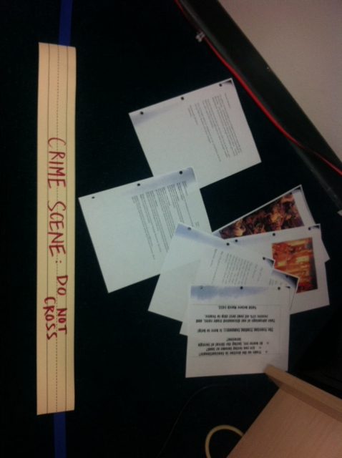
I am a traveler and a history teacher. Previously, I was awarded a grant to present a dream project that could positively shape the 21st century world. My focus for this grant to was to explore the Guanacaste province in Costa Rica to encourage sustainable programs and education services in rural villages. The highlight of my adventure was spent on the rocky shores of Playa Ostional that borders the Pacific Ocean. I spent my time in a small, isolated fishing village watching sea turtles emerge from the ocean in the middle of night to lay the eggs.
The primary objective of our volunteer work was to rescue endangered sea turtles and educate others about the benefits of our work. However, the benefits reached further than just environmental conservation; the experience of living and working with locals in the community cemented the idea that “travel and change of place impart new vigor to the mind.” My six week trip was an immersive experience that renewed a sense how one needs to understand culture to have it and to protect it.

As a partner in this endeavor to share learning experiences, I come with a background in gender history, and I welcome opportunities to discuss and explore the role of women in the past and the future. Working with teenage girls to cultivate a stronger sense of self is also a deep seated passion of mine. Working at an all-girl’s school for many years afforded me a unique opportunity to understand the challenges that many young women face to intellectual growth and a positive self-image. As a means to further develop this passion, I am interested in deepening my understanding of women’s voices in Istanbul and how they changed over time.

By accomplishing this program I hope to bring to life the richness of the culture, the ways in which cultural diffusion has shaped medieval societies and perhaps begin to explore the issues of a modern, global society, with those patterns of interactions in mind. I am fortunate to work at a school that welcomes open discussion of the curriculum, and this experience may lend itself to updating the framework of our 7th grade non-Western history course. As a participant at the Summer Institute, I would like to create a blog to chronicle my educational adventure on our class website: www.thehistoricalworld.weebly.com .
Henry Miller says it best, “One’s destination is never a place, but a new way of seeing things.” Through travel and academic research, I hope to develop a new way of seeing things that better informs my students and positively shapes my teaching practice and their learning experience. With this potential opportunity in Istanbul, not only is the cultural environment rich, but so are the intellectual opportunities to collaborate with teachers and researchers who share a similar vision and have valuable expertise to offer, and I look forward to taking advantage of such a remarkable opportunity to grow.

http://www.socialstudies.org/positions/global/whatisglobaled
http://www.travellingwell.com.au/quotes.html

